Thread List / Text Feed Page:
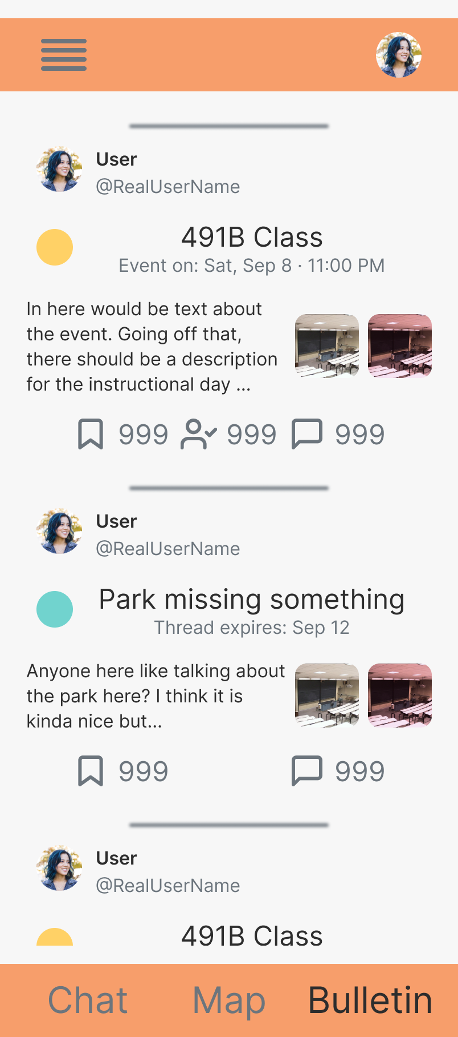

Thread Detail Page:
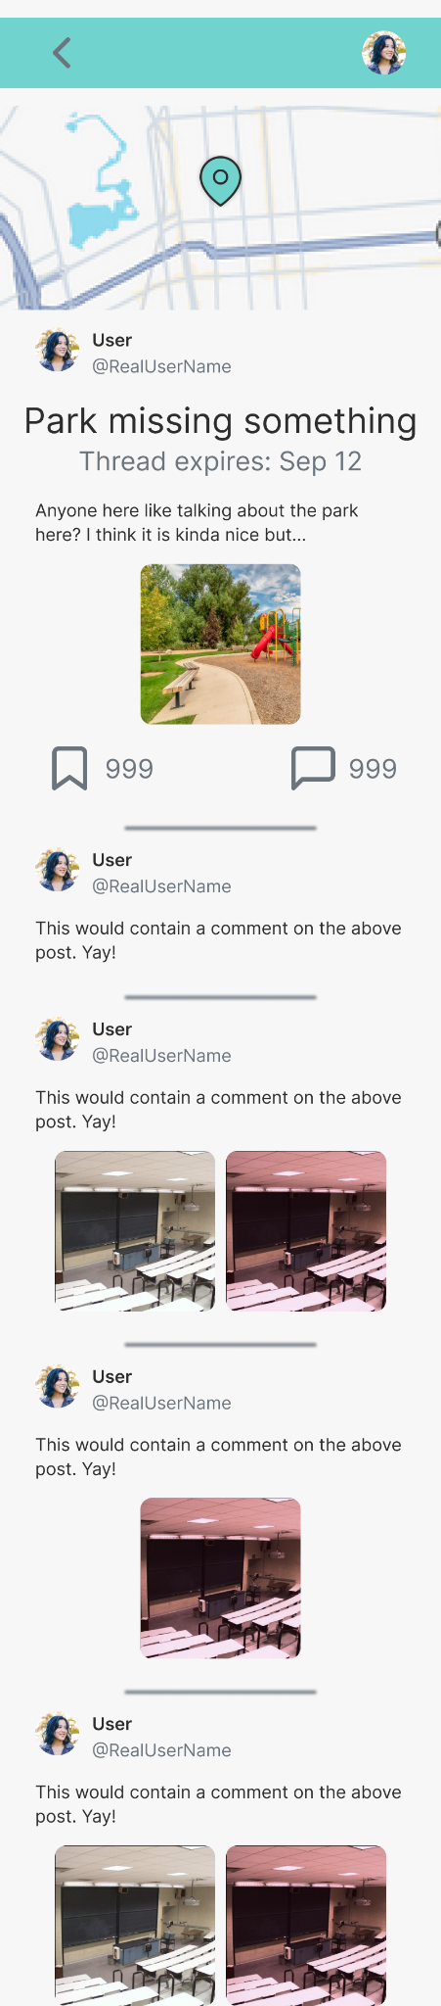

Event Detail Page:
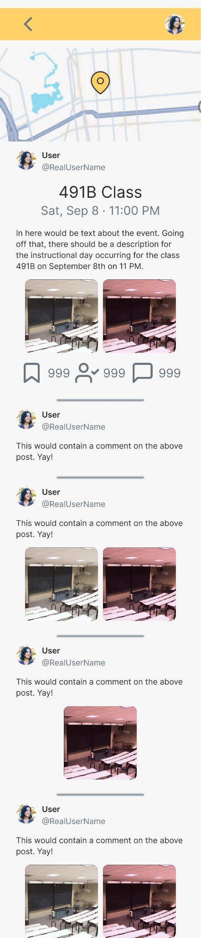

Color Palette:
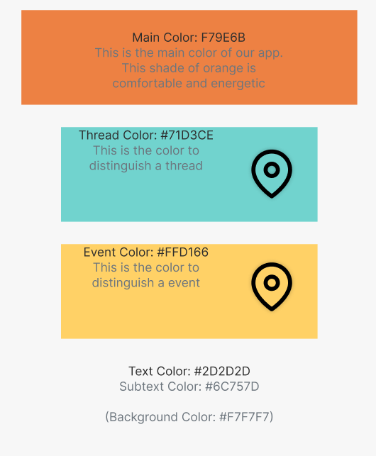

I chose this shade of orange due to the warm energy it gives. It is energetic enough to encourage interaction but more “chill” than red. The other colors were chosen to be easy to work with orange but distinguishable enough so users can quickly determine whether a pin is a thread pin or an even pin.

Figma Link:
https://www.figma.com/design/7Aw0WIHlSKLNuDGbQcf1TS/Untitled?node-id=7-670&t=kISe9vZDtgPXD1Ca-1

